Data Wrangling

Contents

Clean up: 3

Datetime 3

**List** 3

**Dictionary** 4

**Dataframes** 5

**Vlookup** 5

**Selection/Subset of Dataframe:** 5

**Slicing - Filter Row by Row** 7

**Select rows and columns of data frame / slice** 7

**Cosmetic changes to Dataframe:** 7

Rearrange column order 8

**Preprocessing:** 8

**Replace characters :** 8

replace / rename similar values in a column 8

**NANs / Nulls values** 8

String nan 9

**df.fillna()** 9

**df.dropna()** 9

**Drop columns** 10

**Drop Rows with Zero Length Strings** 10

**Drop rows with threshold no. of value** 10

**Drop rows – condition** 10

**Remove rows – string column contain substring** 10

**Row by row:** 11

**iterrows(),apply()** 11

**.apply()** 11

**Duplicates** 12

**Conversions:** 12

**Convert str to int** 12

**Convert strings with comma to numeric** 13

**EDA methods:** 13

**Value_counts:** 13

**NUnique()** 13

**Codify Categorical manually:** 14

**Binning numeric values to categorical variable** 14

**Length of text in new column:** 14

**Remove Rows with Zero Length Strings** 14

**Correlations** 14

**EDA Visualization tips:** 15

**GroupBy** 15

Feature Engineering: Creating a new column 15

df.assign 15

# Clean up:

* convert object (/string) to datetime
  + pd.to_datetime(df[<column>])

# Datetime

* derive transaction hour from date time
  + df['date_time'].dt.hour
* derive day name
  + df['date_time'].dt.day_name()
* derive year-month alone from date time
  + df['date_time'].dt.to_period('M')
    - and groupby count of transactions
      * df_timeline01 = df.groupby(df['year_month'])[['trans_num','cc_num']].nunique().reset_index()

df_timeline01.columns = ['year_month','num_of_transactions','customers']

* derive age
  + np.round((df[“transaction_time”] - df['dob'])/np.timedelta64(1,'Y'))

## **List**

List comprehension:

new_list = [expression for item in iterable if condition == True]

With IF..ELSE()

List2 = [f(x) if condition else g(x) for x in sequence]

Difference between two lists

where List2 is the bigger list and elements in list1

list3 = list(set(list_big) - set(list_small))

Above, any duplicates are removed and besides order of elements also reset.   
If order and duplicates are to be retained then use below.

or

ys = set(y)

list3 = [item for item in x if item not in ys]

## **Dictionary**

Create empty dictionary:

dict = **{** k:**[]** for k in ['name', 'address', 'phone'] **}**

then append values later with:

dict[“name”].append(‘john’)

dict[“address”].append(‘Chicago’)

Dictionary Comprehension

dict = {key: process_fn(key) for key in blob.words}

# create dict processing key in a list or column using process_fn() and put the output as value for the key

print only top values of a big dictionary like df.head()

dict(list(my_dict.items())[:3])

.items() returns an iterator and so converted to a list first

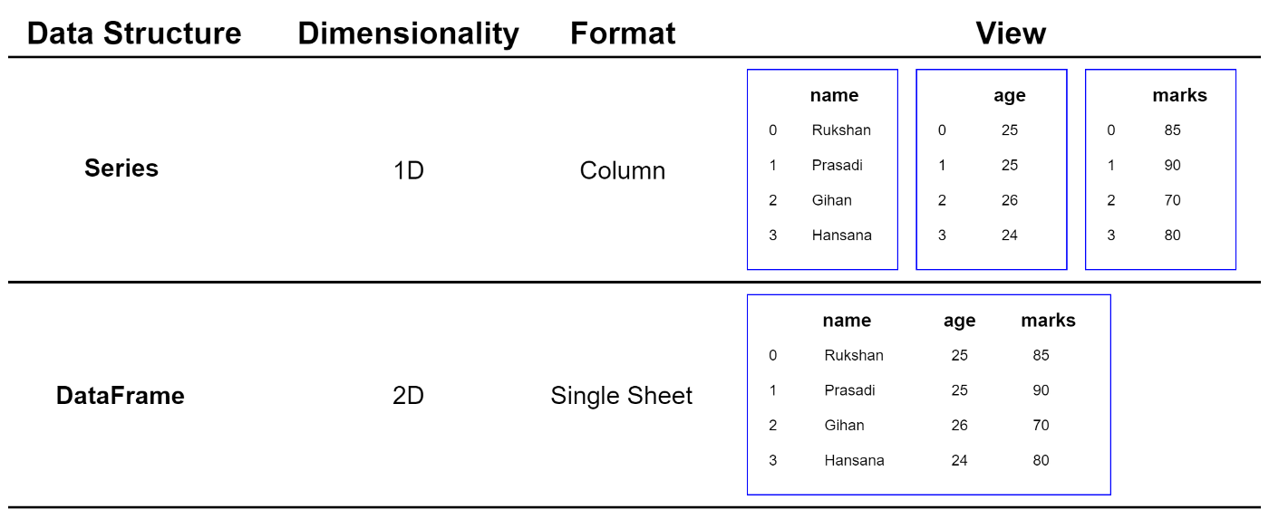

## **Dataframes**

<https://towardsdatascience.com/23-efficient-ways-of-subsetting-a-pandas-dataframe-6264b8000a77>

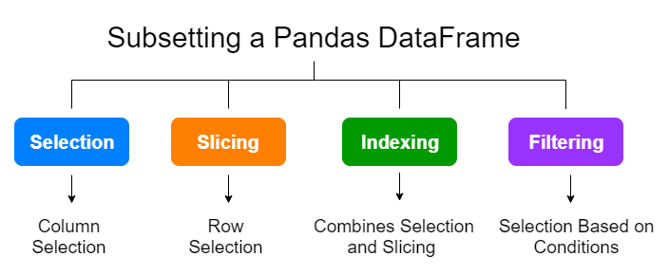

### **Vlookup**

* + merge entire table and with only specific column and foreign key
    - pd.merge(df1, df2**[[**<foreign key>,<column needed>**]]**, left_on=<key>,right_on=<foreign key>,how='left')

merge is equivalent to SQL joins

* Using .map:  
  df_longertable['new_col’] = df_longertable.user_id.map(df_small.type)

### **Selection/Subset of Dataframe:**

#### **A. Single value**

1) Simple approach to accessing a specific value in df:

Df[‘column name’][row_index_value]

Note: this method is not very reliable and besides here is it [column] [row] while in more widely used syntaxes it is [row, col]

2) loc/iloc

**df.loc['row_label', 'column_label']**

Access a group of rows and columns by label(s) or a boolean array.

.loc[] is primarily label based, but may also be used with a boolean array.

**Allowed inputs are:**

* A single label, e.g. 5 or 'a', (note that 5 is interpreted as a label of the index, and never as an integer position along the index).
* A list or array of labels, e.g. ['a', 'b', 'c'].
* A slice object with labels, e.g. 'a':'f' Note: here that contrary to usual python slices, both the start and the stop are included

**df.iloc['row_index', 'column_index']**

#### **B. Single Column as Series**

1) Specific column as Series:

col = df[‘<column>]

**A series item is returned**

#### **2) Single/Multiple columns as DF**

mul_cols = df**[** [<col1>,<col2>] **]** #note double brackets []

A dataframe item is returned

The first looks for a specific Key in your df, a specific column, the second is a list of columns to sub-select from your df so it returns all columns matching the values in the list.

#### **3) .loc**

**Syntax: df.loc['row_label', 'column_label']**

single: df.loc[:, 'alcohol'] - **Returned as Series**

**Multiple**: df.loc[:, ['alcohol', 'ash', 'hue']] - **Returned as DF**

#### **4) .iloc**

**Syntax: df.iloc['row_index', 'column_index']**

Single: df.iloc[:, 0] - **Returned as Series**

**Multiple**: df.iloc[:, [0, 2, 10]] - **Returned as DF**

### **Slicing - Filter Row by Row**

1) Condition

df = df **[** ***df[‘column]*** >= 1000 **]**

The condition within outer [] returns a series of Boolean values which is used like a index to include/exclude each row and output

2) isin()

new_df = df[ df["col"].isin([2, 3]) ]

### **Select rows and columns of data frame / slice**

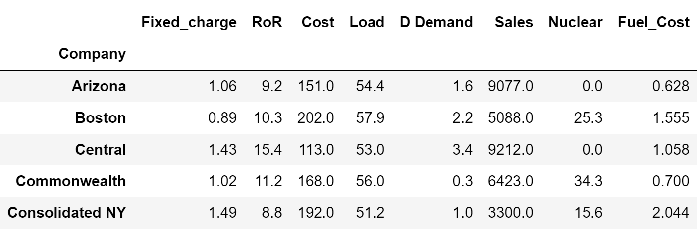

df_clusterA = utilities_df_norm.loc[slice("Arizona","Boston"), ["Sales","Fuel_Cost"]]

df_clusterB = utilities_df_norm.loc[["Central","Commonwealth","Consolidated NY"], ["Sales","Fuel_Cost"]]

# **Make New Column:**

**1) Make New Col based on presence in list**

df['new_bool_col'] = df['user_id'].apply(lambda x: 1 if x in buyers_list else 0)

**2) Make Boolean col based on sum of 3 cols being > 0**

df['new_bool_col'] = df[['col1', ‘col1’, ' col3']].sum(axis=1).apply(lambda x: 1 if x > 0 else 0)

**3)** **Compare 2 columns and 0 if columns are same and 1 if different**

df['Comparison'] = df.apply(lambda row: 0 if row['Column1'] == row['Column2'] else 1, axis=1)

# **Cosmetic changes to Dataframe:**

## Rearrange column order

df.reindex([<the new ordered list of columns> ], axis="columns")

note: changes are inplace

# **Preprocessing:**

## **Replace characters :**

In whole df:

import numpy as np

df = df.replace("?", np.nan).copy()

## replace / rename similar values in a column

df.columnname.replace(‘value_to_be_changed’, ‘new_value’)

## **NANs / Nulls values**

(1) Using **isna()** to select all rows with NaN under a *single* DataFrame column:

df[df['column name'].isna()]

(2) Using **isnull()** to select all rows with NaN under a *single* DataFrame column:

* df[df['column name'].isnull()]
* df.isnull().sum(axis = 1)

(3) Using **isna() and isna().sum()** to select all rows with NaN under an *entire* DataFrame:

1. df.isna().sum() #list all the columns and total of NA count
2. #or
3. df[df.isna().any(axis=1)]

(4) Using **isnull()** to select all rows with NaN under an *entire* DataFrame:

1. df[df.isnull().any(axis=1)]

### String nan

when preprocessing text and saving to column, sometime ‘nan’ gets saved as a string dtype and it does not get detected with isna() or dropna() but below works

df0.fillna('', inplace=True)

### **df.fillna()**

simple, identify cols with na, create a list of these cols, use the list name as below to fill it

1. cols_to_fill_zero = [‘column1’, ‘column2’, ‘column3’]
2. df[cols_to_fill_zero] = df[cols_to_fill_zero].fillna(0)
3. fillna with the most common value of a column
4. df = df.apply(lambda x:x.fillna(x.value_counts().index[0]))

b. fillna with mean of the col: done column by column and not in mass

1. df[column1] = df[column1].fillna( df.column1.mean() )

### **df.dropna()**

**Drop all rows having at least one null value**

[pandas.DataFrame.dropna()](https://pandas.pydata.org/docs/reference/api/pandas.DataFrame.dropna.html) : drop all rows with at least one missing value.

**Drop rows having only missing values**

columns’ values are all null, then how='all'

**Drop rows where specific column values are null**

If only specific columns, then subset argument.

For instance, let’s assume we want to drop all the rows having missing values in any of the columns colA or colC :

1. df = df.dropna(subset=['colA', 'colC'])
2. print(df)

Additionally, you can even drop all rows if they’re having missing values in both colA and colB:

1. df.dropna(subset=['colA', 'colB'], how='all', inplace=True)
2. print(df)

### **Drop columns**

del train_df['PassengerId']

## **Drop Rows with Zero Length Strings**

df = df[~df[‘colA’].eq('')]

df = df[df[‘colA’].ne('')] #ne – not equal

ID columns with string (na or zero length)

missing = (data['text'].isna()) | (data['text'].str.len() == 0) #generator?

### **Drop rows with threshold no. of value**

Finally, if you need to drop all the rows that have at least N columns with non- missing values, then you need to specify the thresh argument that specifies the number of non-missing values that should be present for each row in order not to be dropped.

For instance, if you want to drop all the columns that have more than one null values, then you need to specify thresh to be len(df.columns) — 1

df = df.dropna(thresh=len(df.columns)-1)

print(df)  
 colA colB colC colD  
1 False 2.0 b 2.0  
2 False NaN c 3.0  
3 True 4.0 d 4.0

### **Drop rows – condition**

df = df.drop(some labels)

df = df.drop(df[<some boolean condition>].index)

Single condition:

df.drop(df[df.score < 50].index, inplace=True)

Multiple condition: & | ~

df = df.drop(df[(df.score < 50) & (df.score > 20)].index)

## **Remove rows – string column contain substring**

1: select Rows that Contain a Specific String

df[df["col"].str.contains("this string")==False] #errors out

mask =  df.apply(lambda x: x.str.contains('Chicago').any(),axis=1) #axis=0 selects columns

sub_df = df.loc[: , mask]

2: seelct Rows that Contain a multiple Strings

df[df["team"].str.contains("A|B")==False]

3. **remove Rows that Contain a Partial String**

#identify partial string to look for

discard = ["Wes"]

#drop rows that contain the partial string "Wes" in the conference column

df[~df.conference.str.contains('|'.join(discard))]

# **Row by row:**

## **iterrows(),apply()**

<https://medium.com/@filipgeppert/for-loop-in-pandas-a-k-a-pd-apply-e4a53f62d78d>

NOTE: When using iterrows and UDF

How does .iterrows() work?

for index, row in df.iterrows():  
 # Access any cell in row and set it to 0  
 df.loc[index, 'column_name'] = 0

for index, row in df.iterrows():  
 # Access any cell in row and set it to 0  
 # Check if value in cell fulfils condition  
 if df.loc[index, 'column_name'] == 1:  
 df.loc[index, 'column_name'] = 0  
 else:  
 pass

## **.apply()**

1. df[‘new column’] = df[‘old’].apply(lambda x: re.findall(“\s\S@+\.\w{2,3}”, text)

.apply() is a Pandas way to perform iterations on columns/rows. It takes advantage of vectorized techniques and speeds up execution of simple and complex operations by many times.

df[‘month’] = df['date'].apply(lambda x: x.month)

#### **.apply() with condition**

# Create function that checks multiple conditions   
def extract_month(x):  
 month = x.month  
 if month == 11:  
 return “It’s november. So cold!”  
 elif month == 6:  
 return “It’s june. I love sun!”  
 else:   
 return “It’s ok.”# Apply function on column  
df[‘month’] = df.date.apply(extract_month)

#### **.apply() on multiple cells in row**

# Calculate mean price per day  
def mean_cost_per_day(row):  
 mean_cost = np.mean([row.price_day, row.price_night])  
 return mean_costdf[‘mean_cost_per_day’] = df.apply(mean_cost_per_day, axis=1)

#### **Row by Row : Conditional String manipulation**

df['new_col'] =   
df['old_col'].where(df['old_col'].str.startswith('1.4'), df['old_col'].str[:3])

## **Duplicates**

sum(epl_matches.duplicated())

## **Conversions:**

### **Convert str to int**

Note: cells with N/A will throw error for astype()

astype (all values must be convertible to int else error)

df['Price'] = df['Price'].astype(int) #singlecolumn

df[ ['Price',’date’,’name’] ] = df[['Price',’date’,’name’]].astype(int) #multiple and this does not lead to losing columns not mentioned in the subset. Rest of df is retained

pd.to_numeric

Note: cells with comma in the string ‘1,000,004’ will be replaced by NaN

df['Price'] = pd.to_numeric(df['Price'],errors='coerce') #coerce puts non-convertible values as Nan

df[cols] = df[cols].apply(pd.to_numeric, errors='coerce') #single

df[ ['Price',’date’,’name’] ] = df[['Price',’date’,’name’]].apply(pd.to_numeric, errors='coerce') #multiple

### **Convert strings with comma to numeric**

df.apply(lambda x: x.str.replace(',', '').astype(float), axis=1)

# **EDA methods:**

Describing DF - <https://medium.com/codex/9-efficient-ways-for-describing-and-summarizing-a-pandas-dataframe-316234f46e6>

Inspecting DF - <https://medium.com/codex/10-efficient-ways-for-inspecting-a-pandas-dataframe-object-3f66563e2f2>

### **Value_counts:**

Groupby distinct items and count

train_df['Embarked'].value_counts()

S 644

C 168

Q 77

Name: Embarked, dtype: int64

### **NUnique()**

print unique item count

1. td.nunique()
3. Output:  
   PassengerId 1309
4. Survived 2
5. Pclass 3
6. Name 1307
7. Sex 2
8. Age 98
9. SibSp 7
10. Parch 8
11. Ticket 929
12. Fare 281
13. Cabin 186
14. Embarked 3
15. dtype: int64

### **Codify Categorical manually:**

# convert label to a binary numerical variable

citation['violation_flag'] = citation.violation.map({'Warning':0, 'Citation':1, 'ESERO':2})

### **Binning numeric values to categorical variable**

#convert continuous numeric data to categorical

df ['new] = pd.cut(x=df ['polarity'],bins=[-1, -0.05, 0.05, 1], labels=['Negative', 'Neutral', 'Positive'])

bins = [0,1,2,3,7,31,365,np.inf]

bin_names = ['D0','D1','D2','D3-D6','Month1','Year1','Year1+']

df['new_col'] = pd.cut(df['col'], bins, labels=bin_names, include_lowest=True, right=False) #include_lowest ensures left most value is included in bin

#### **Col.replace()**

Replace categorical values with numbers or other

sampleDF.housing.replace(('yes', 'no'), (1, 0), inplace=True)

## **Length of text in new column:**

passfail_df['comm_length'] = passfail_df['violation comments'].apply(len)

## **Remove Rows with Zero Length Strings**

df = df[~df[‘colA’].eq('')]

## **Correlations**

Remove correlated features to reduce multi-collinearity

## **EDA Visualization tips:**

**SNS Missing values Heatmap:**

1. import seaborn as sns
2. td.isnull().sum()
3. sns.heatmap(td.isnull(), cbar = False).set_title("Missing values heatmap")

## **GroupBy**

Groupby and then convert the grouped data into a dataframe

df_new = df_old.groupby(“col1”)['event_name'].apply(','.join).to_frame()

# Feature Engineering: Creating a new column

## df.assign

df.assign(new_col_name= value/formula on existing_col/lamda of another column)

>>> df

temp_c

Portland 17.0

Berkeley 25.0

>>> **df.assign(temp_f=lambda x: x.temp_c * 9 / 5 + 32)**

temp_c temp_f

Portland 17.0 62.6

Berkeley 25.0 77.0

Or directly refer to multiple columns with a formula

**df.assign(temp_f=lambda x: x['temp_c'] * 9 / 5 + 32,**

**temp_k=lambda x: (x['temp_f'] + 459.67) * 5 / 9)**

temp_c temp_f temp_k

Portland 17.0 62.6 290.15

Berkeley 25.0 77.0 298.15